The AI Black-Box Recorder: Building Immutable Data Lineage and Cognitive Audit Trails
Connecting what enterprise AI consumed with what it ultimately did.
Traditional application logs capture deterministic workflows around a specific API call. Enterprise AI systems are more challenging to reason about in retrospect: prompts are assembled from dynamically retrieved evidence, model outputs change with input, and autonomous agents are empowered to make irreversible decisions. An audit must answer not only "what API was called" but also "under what context" and "with what evidence" in order to trace an action back through the supply chain.

This requires both an upstream provenance ledger for the data fed to models, and a downstream black-box recorder for their effects:

Provenance Before Intelligence
Provenance tracks assets before they are transformed by AI. When initially ingested, the enterprise stores the original data, produces a deterministic normalized representation, and classifies it according to ownership, sensitivity, geography, licensing, allowable use, and retention. The pipeline extracts chunks of content, producing three linked identifiers: a source hash for the original asset, a content hash for each transformed chunk, and a derivation ID recording what transformation code, configuration, and position produced it.

A manifest containing these identifiers and associated governance metadata should be signed by an HSM- or KMS-protected service account and appended to a Merkle-based transparency log. Signed tree roots and inclusion proofs can detect any deletion, replacement, or rewriting, like RFC 9162 certificate transparency logs. The actual raw document should be placed in an encrypted write-once-read-many evidence vault, while the ledger stores hashes, signatures, policy, and pointers to verifiable data.

For RAG, every vector ID is associated with its content hash, embedding model version, index snapshot, and receipt from the ledger. For fine-tuning, a signed manifest connects the resulting model to its approved data and processing pipeline versions. These records can take the form of W3C Entity–Activity–Agent triples or OpenLineage dataset/job/run events, depending on the lineage format used.

Hashing alone is insufficient for enterprise-grade evidence chains. Data requires not only cryptographic integrity but also durable storage, retention enforcement, independent auditing, access control, and separation of duties.

End-to-End Architecture:
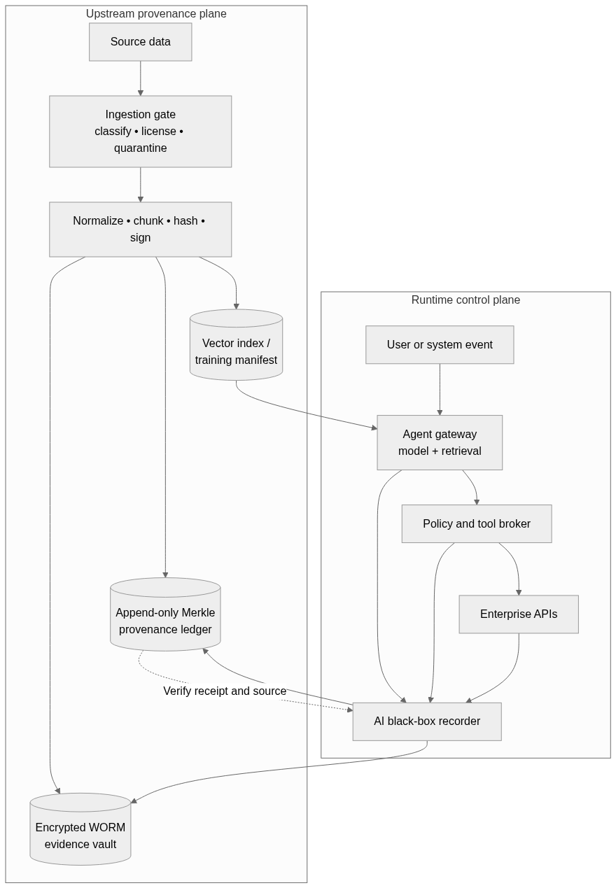

Evidence Before Execution
The black-box recorder should capture execution at the point where no other tool can observe it. Since agents typically do not act directly but through credential-privileged infrastructure, every database write, email send, payment, API call, or infrastructure change should pass through a policy-enforcing mediator.

For every tool call, this recorder captures the authenticated principal, model and agent versions, encrypted prompt envelope, retrieved vector IDs and rankings, provenance receipts, policy verdict, human approvals, proposed tool call, destination, external request ID, response status, and resulting content hash.

A two-phase commit process records an auditable intent before executing any high-risk actions. Only after durable logging of the INTENT event should the recorder attempt to perform the possibly-irreversible RESULT operation. Low-latency read-only operations might use signed async buffers.
INGEST(data):
receipt = LEDGER.append(SIGN(hash, rights, retention))
INDEX.link(vector_or_model_id, receipt)

ACT(tool_call):
intent = SIGN(trace, model, context_receipts,
policy_verdict, tool_call)
REQUIRE RECORDER.commit(intent) if HIGH_RISK
result = BROKER.execute(tool_call)
RECORDER.append(HASH(result), previous=HASH(intent))
The black-box recorder should not record hidden reasoning as definitive evidence. A model's internal context or instruction following cannot be reliably reconstructed from its outputs. Researchers have explored ways to capture and verify "chain of thought" proofs by recording observed evidence, model configurations, prompts, retrieved context, policy decisions, and downstream effects, rather than internal reasoning.

Closing the Loop
If an agent inadvertently exfiltrates PII through an unapproved channel, the enterprise will want to find all data flowing to that external request ID. The runtime trace contains the prompt leading to the decision, along with the policy verdict and vector IDs retrieved. Those in turn can be followed back through the cryptographic ledger to their source documents, transformations, licenses, and approvals.

The enterprise could then quarantine those data sources, invalidate any downstream vectors or models, and collect all evidence leading to the unauthorized disclosure. This establishes a chain of custody from the data to the model to the action. While this shows what information influenced the agent, it does not capture direct mathematical relationships between specific training data items and model outputs. Tying specific tokens or weights to a base-model prediction remains an open research challenge.

Aligned with NIST GAIP and the EU AI Act's high-risk documentation requirements, this architecture lets enterprises satisfy regulatory compliance while building practical accountability. Its true value lies not in reading minds but in creating an auditable trail of evidence, context, and decisions that any AI system understands..

